KS2/3: Discovering DNA
Background on DNA
- DNA stands for Deoxyribonucleic Acid
- It is a set of instructions for every living thing (present plants, fruit, animals, bacteria etc.)
- DNA contains genes, located in exons, and a specific sequence or code of DNA will form a specific gene that can be transcribed into mRNA (messenger RNA). This is then translated into a sequence of amino acids that form the proteins that are the building blocks of all living organisms. Proteins form enzymes, antibodies, and form structural components of muscle, hair, just to name a few examples.
- The proteins that form from DNA and genes are what determine the way you look, your hair colour, height, blood type.
- Our DNA is inherited 50% from your biological mother and father. When fertilized, an egg and sperm will combine their respective DNAs to develop an offspring with a unique set of DNA code (with the exception of identical twins)

Who discovered DNA?
- Watson and Crick at Cambridge University, 1953 - based their work on an x-ray diffraction image taken by Rosalind Franklin and Raymond Gosling.
- Franklin and Gosling's image is a ‘spotty cross’ from which it is difficult to see how the DNA structure was calculated.
- Watson and Crick published the first paper describing DNA structure, entitled ‘Molecular Structure of Nucleic Acids: A Structure for Deoxyribose Nucleic Acid’. They used X-ray crystallography and mathematics to show that DNA has a ‘double helix structure’

What is the structure of DNA?
- DNA’s shape is known as a double helix, and it looks like a twisted ladder or spiral
- It is made up of four chemical subunits known as nucleotides, which form the ‘code’ of the DNA. The backbone surrounding the nucleotides is a combination of sugars and phosphates, known as the phosphate-deoxyribose backbone.
- The four nucleotides are Adenine (A), Cytosine (C), Guanine (G), and Thymine (T).
- A pairs with T, and C pairs with G

Where is it found?
- DNA is found in almost every cell in ever living organisms.
  - A notable cell type without any DNA is the red blood cells, which has evolved to not have a nucleus or DNA, to give it as much room as possible to carry iron and oxygen.
- A nucleus is a cellular organelle contained within these cells, and acts like the brain of the cell, containing almost all of the DNA required to make any cell in our body.
  - Interestingly the mitochondria, another cellular organelle that acts as the powerhouse, has it’s own DNA (mitochondrial DNA, mtDNA)
- Within the nucleus, DNA is wrapped up into structures called chromosomes. These include proteins such as histones that can be modified to change how tightly certain sections of DNA are wrapped around these structures, this is called epigenetics and helps decide which genes are switched on or off.
  - Epigenetics is the process that explains how we have lots of different types of cells in our body, even though they all have the same DNA.
- We have 46 chromosomes from a human cell (23 pairs, each pair has a copy from your mother and father). If all chromsomes were uncoiled and placed end to end, the DNA would be 2 meters long and 2 billionths of a meter wide.
  - If the DNA from every cell in your body (37 trillion) was put end to end, it would reach the moon and back over 800 times.
- Our DNA is 50% similar to that of a banana, 98% similar to a chimpanzee, and 99.9% similar to other humans. That 0.1% accounts for all of the differences that we see between each other.

Why is it important that we understand DNA?

- Some diseases are caused by faulty DNA
  - Down syndrome, Cystic Fibrosis, Huntington’s Disease, cancer etc.
  - There are examples of those that we are born with, and those that develop in adulthood as a result of mutations to our DNA and the regulation of gene expression.
  - The more we understand about DNA in a normal situation, and the changes seen in disease, then we can develop ways of preventing and treating the disease itself.
- Gene transfer helps to make proteins, such as the one that makes blood clot
- Genetically-modified (GM) crops can resist pest attacks or weed-killers

Questions about DNA

- What does DNA look like? [a double helix]
- Who discovered the shape of the DNA molecule? [Watson, Crick, Wilkins, Franklin]
- Where was the discovery announced? [The Eagle pub in Cambridge]
- And when? [1953]
- What is in the DNA molecule? [Adenine, Cytosine, Guanine, Thymine]
- Where is DNA found? [In almost every cell in our bodies]
- Where do you get your DNA from? [From your Mum and Dad]
- What does DNA do? [It contains instructions to make chemicals that make our bodies]
- How similar is human DNA to banana DNA? [About 50%]
- How similar is human DNA to monkey DNA? [About 98%]
- How similar is your DNA to my DNA? [About 99.9% - more if you’re related]

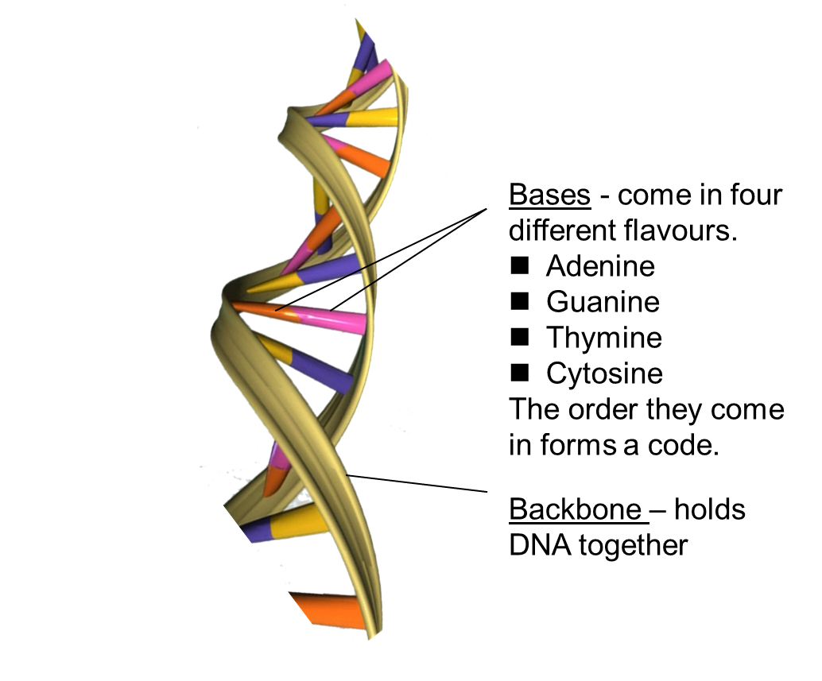
(Image source - https://en.wikipedia.org/wiki/File:DNA_Double_Helix.png)

