Babraham Institute Animal Facility Challenges: Cage Wash Robot

The Babraham Institute’s state-of-the-art Biological Support Unit (BSU) provides housing and care for up to 50,000 pathogen-free rodents used in both the academic scientific research programmes and by private companies. http://www.babraham.ac.uk/science-services/biological-support-unit
The BSU is made up of four bioscience units, each performing a unique role in the provision of flexible services to meet the dynamic requirements of biological research. The bioscience units surround the central services unit which utilises robotic cage-washing technology and automated sterilisation processes to provide equipment and consumables to each of the animal holding areas.

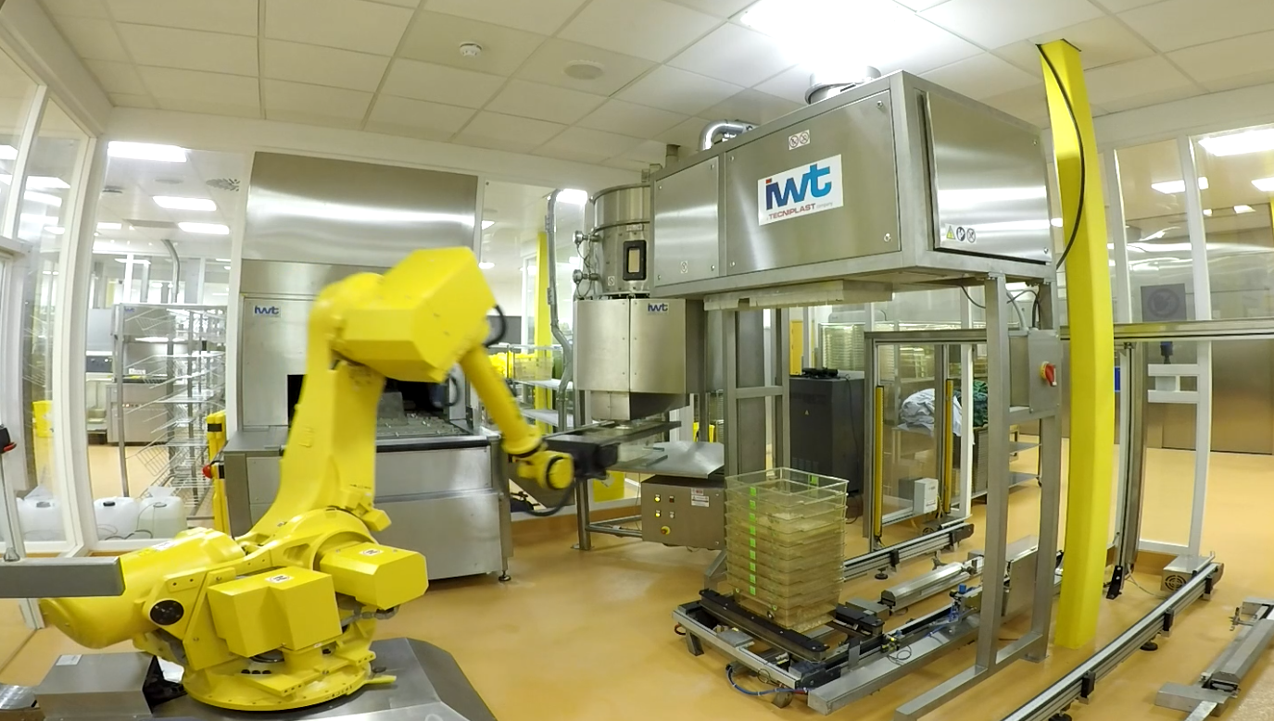

The robot picks up dirty cages from a trolley, empties the soiled bedding into a disposal chute and then places the cages onto a conveyor belt leading into a cleaning system. When all the cages have been removed the trolley is also passed through the cleaning system. A similar robot (pictured above) removes the cleaned cages from the conveyor belt, places them under dispensers for sawdust and nesting material before stacking them back onto a new trolley for sterilisation by autoclave.

Your challenge: Build a working LEGO model of a cage washing robot and create a set of instructions to allow the Babraham Institute (and others) to build and program their own version for use in schools and at careers events.

