Basic Budding Yeast Culture

Yeast are grown on solid agar plates or in liquid culture.

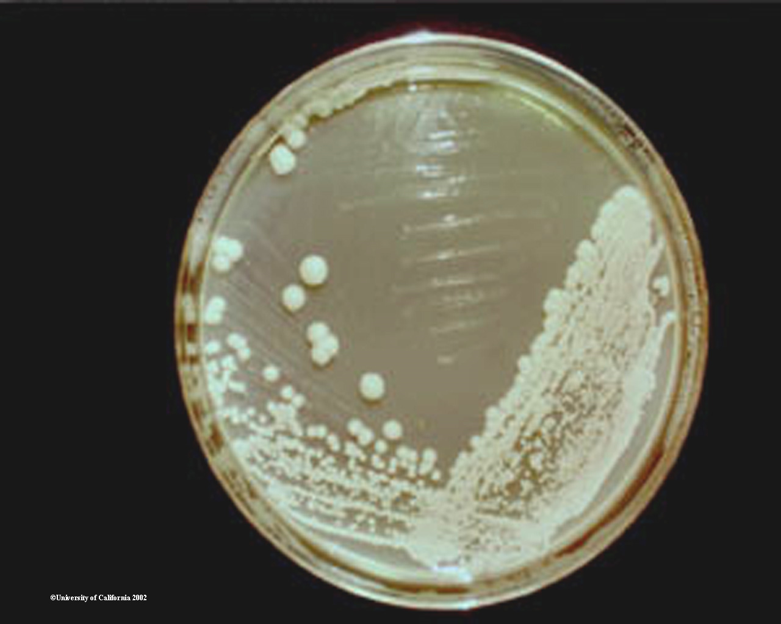
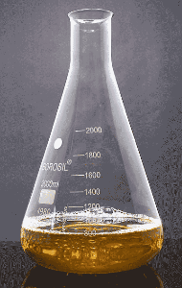
Solid agar plates - 9cm diameter plastic Petri dishes filled with solidified media. Plastic disposable loops are used to streak yeast on agar plates, they are then inverted and put in an incubator at 25° or 30° until colonies ~1mm across have formed. For wild-type strains at normal growth temperatures on rich media this takes 2 days. Yeast cells should be white or pink, dependent on the strain.

Liquid culture - Cells are grown in a flask or tube in an incubator while shaking at ~200rpm. Flasks should be no more than half full. Cultures are inoculated with a small quantity of cells, and grow eventually to saturation over a day or two.

How fast do yeast grow? Pretty fast, but it depends heavily on media, temperature, strain, etc. To follow growth in liquid culture, the yeast cell density is measured by the optical density at 600nm (OD₆₀₀). Cells go through a few different growth phases:

Lag phase –cells growing slowly (on a plate or in a saturated culture) take time to reach maximum growth rate, so when cells are initially added to a liquid culture they grow very slowly. Depending on the media and the cells this can last many hours. Cells gradually speed up until they reach maximum growth in log phase.

Log phase – cells are growing as fast as they can. This is almost always the correct growth phase to harvest cells for experiments. Mid-log is best, corresponding to an OD₆₀₀ of 0.4-0.9 (for very sensitive experiments 0.5-0.7). It is important to harvest cells at mid-log as gene expression profiles are very dependent on growth phase. If cells are above 0.7 but still growing (OD<2), dilute to OD 0.3 and let grow to 0.6 before harvest. During log phase, cells grow with a defined doubling time - the time that the number of cells present takes to double. The doubling time varies with media and cell type – healthy cells growing in rich media at 30° have a doubling time of 90 minutes or less, but unhappy mutants can have doubling times of many hours.

Late log phase – cells are starting to run out of sugar and slow down growth. If large quantities of cells are required for insensitive experiments (eg. isolating a protein complex), this growth phase is usually ok. Corresponds to OD₆₀₀ 0.9-2 (actually in our hands much higher…).

Approaching stationary phase – cells are really running low on sugar (or other limiting nutrient), and grow very slowly. Except for specialised applications, do not use cells in this phase (above OD₆₀₀ 2), although for DNA extractions stationary phase cells are fine. Cells do not die in stationary phase, even when the culture is saturated, they just stop dividing. So if diluted into fresh media they will start to grow again, albeit with a lag phase at the start.
Growth temperatures

30° - budding yeast’s normal growth temperature
25° - also a good growth temperature, required for working with some mutants.
23° - often required for maintaining temperature sensitive strains.
18° - will prevent growth of cold sensitive (cs) strains
37° - will prevent growth of temperature sensitive (ts) strains

Measuring optical density

This is done by putting about 1ml of cells in a disposable cuvette and reading in a spectrophotometer, compared to a negative control, which is a sample of the media containing no cells. For OD₆₀₀ 0.05-1.0, the reading is roughly proportional to cell number, but above this it gives an underestimate. For cultures with an OD₆₀₀ above 1.0, it is wise to dilute 1:10 and re-measure. Tables exist to convert OD₆₀₀ readings into actual cell densities for more accurate calculations. Beware – we have two spectrophotometers that differ by ~0.2 on the same sample. Stick to one or other.

A simple method for growing cells to mid-log

Harvesting cells at mid-log is very important, but can be tricky because of the different growth phases, lag phases, etc. The following methods are straight forward and reliable for most cells in most experiments and give reproducible results.

1) Pick a single colony from an agar plate with a plastic loop and inoculate 4ml liquid media in a 14ml culture tube. Place at 30° in a shaking incubator over the weekend. This gives a pre-culture which can be kept at room temperature for 2-3 weeks. It should be at stationary phase, though some very sick strains may require longer growth. After a few hours sitting on the bench, all the yeast should settle to the bottom of the culture; if not, the culture is contaminated and should be discarded. In the evening, vortex the pre-culture until the yeast is evenly distributed. Dilute in the required amount of media and place in a shaking incubator at the required temperature. For wild type yeast being grown in YPD at 30°, 1:20,000 is about the correct dilution. The next morning, the cells should be near mid-log. When growing a strain for the first time, pick a dilution and set a test 4ml overnight culture. Based on the OD in the morning, the correct dilution can be calculated, for example, if you set a culture at 1:20,000 and the following morning the OD is 0.125, then reset the culture at a four fold lower dilution (1:5,000) next time. For a given strain growing in the same media at the same temperature, the required dilution varies very little. If a required dilution of less than 1:200 is calculated, extend the growth time instead – going below 1:200 does not give the cells time to come out of stationary phase properly. This is often the case for sick strains growing on synthetic media.

2) (This is my preferred method) Grow cells on a plate. In the morning inoculate a colony into 4ml media and let grow for 6-8 hours at 30º with shaking. At this point the OD should be in the range 0.2-1. Dilute into a 25ml culture of the same media in a 50ml flask (or larger if needed), grow overnight at 25ml with shaking. Standard dilutions are 1:20,000 in YPD or 1:2,000 in synthetic media, with a correction for the OD of the cells prior to dilution.

Contamination and sterility

Yeast love their growth media, but so do plenty of other micro-organisms, so working under sterile conditions is important. On the bright side, yeast are not as sensitive to contamination as other eukaryotic cell culture systems as yeast in their own media will outgrow most other things.

For spreading cells on solid plates, no special precautions are necessary, as usually contamination is very visible - contaminants will grow into a funny coloured splodge on the plate. If this happens, just re-streak the cells on a new plate while avoiding the contaminant.

When setting up a liquid culture, more care is required:

Work close to a Bunsen burner set to a blue flame or in a laminar flow hood.

Set up an extra culture and don’t inoculate it – if anything grows, then your sterile technique needs work.

Swirl bottles of media before use, if they go cloudy then discard.

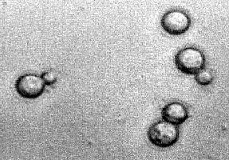
Yeast settle to the bottom of a tube if left on a desk for a few hours – if this does not occur then the culture is contaminated.

If you suspect contamination, pipette a few microlitres of culture on a glass slide, add a coverslip and examine under a 100x microscope. Budding yeast look like this (see picture), anything else is contamination. Discard the culture.
How to keep yeast

Yeast on plates are happy in the fridge for a reasonable period, but will need re-streaking about once a month (the plates will start to dry out). When the plates start to smell, re-streak them.

For longer storage, make glycerol stocks:
Grow a liquid culture to stationary phase
Mix 500μl of the culture with 500μl sterile 30% glycerol in a 1.5ml screw cap tube
Write the stock number on the top and the strain genotype on the side
Place tube in a box in the -80° freezer

To get cells from glycerol stocks:
Remove a small amount of the stock with a plastic loop
Put in a patch on an agar plate.
Let grow for a few days then streak out.
DO NOT LET GLYCEROL STOCKS THAW AND REFREEZE.

Although strains can be maintained by continual re-streaking at 4°, it is wise to return to the glycerol stock periodically (avoids problems with mutation and contamination).

Slants are an alternative to glycerol stocks – they do not last quite as long, but avoid the strange effects occasionally seen with freeze-thawed cells. A slant is simply 1ml YPD-agar in a 2ml tube solidified at about a 45° angle to increase the surface area (hence the name slant). Dry well by leaving the open tubes for a few hours in a 45°C oven, streak some yeast on the agar, close the tube and grow cells upside down at 25° or 30°. Once a good lawn of yeast is obtained, keep the tube inverted at 4° (for years).

Types of media

Budding yeast are grown on two types of media, rich or synthetic

Rich media allows faster growth, but results can be more variable due to variations in the media.

Synthetic media gives slower growth, but allows precise control of constituents. Because synthetic media allows omission of nutrients, synthetic media is required for selection by auxotrophic markers (see later) and for maintaining plasmids.

All media contains a carbon source (usually a sugar). These are the normal ones:

Glucose: Yeast’s favourite sugar, this is used by default. Glucose causes the repression of genes used to metabolise other sugars (e.g. galactose). Yeast metabolise glucose by anaerobic fermentation. Historically glucose was called dextrose, and therefore the abbreviation for glucose is still D.
Galactose: Used to grow strains with a gene under the control of galactose responsive promotor (P_{GAL}). Galactose is also fermented.
Raffinose: A semi-fermentable carbon source that supports reasonable growth rates, does not repress genes for utilising other carbon sources. Often used as a 1:1 mixture with sucrose
Glycerol: A non-fermentable carbon source that forces the yeast to grow aerobically. Growth on rich glycerol media is not too slow, but synthetic glycerol media gives very slow growth. Note that cells growing on glycerol media require more aeration, so use a flask 5x the volume of media, and do not use culture tubes.
Acetate: Potassium acetate is another non-fermentable carbon source. This supports much better growth than glycerol and is more generally useful, but see notes on glycerol above regarding aeration.
Other sugars: Sucrose is fermentable but rarely used, not sure why, I use it often instead of raffinose. Lab strains cannot ferment maltose, but can if given a MAL63 plasmid. Ethanol and lactate are non-fermentable carbon sources that suck for growth.

NOTE: Because glucose can be fermented anaerobically, budding yeast can actually survive without mitochondrial DNA (though not very well). Strains lacking active mitchondria are described as petite. They are very slow growing. Strains that suddenly pick up a growth defect have normally become petite, which is irreversible. Re-streak again from the glycerol stock. In general, avoid small colonies when re-streaking plates.

Synthetic media also contains a nitrogen source – this is usually ammonium sulphate, but other sources such as proline and GABA can be used under certain circumstances. Growing cells in alternative nitrogen sources tends to be a pain.

If cells become heavily contaminated with bacteria, they can be cured by growth on plates containing 50µg/ml ampicillin. Yeast is not sensitive to ampicillin.
Making media

All media components listed here can be bought from Formedium

Naming conventions:

Rich media is called YPx where x is the sugar – D for glucose, S for sucrose, G for galactose, A for acetate, Gly for glycerol, R for raffinose.
Synthetic media is called Sx where x is the sugar as above. Then –U/L/H etc. to represent any supplements the media is lacking.

Liquid media:

For rich media: 2% peptone
1% yeast extract
2% sugar

Or for synthetic media: 6.9g/L yeast nitrogen base (Formedium)
Xg/L amino acid mix (Formedium)
2% sugar

Weigh these, add water, stir to dissolve and filter sterilise. You can also sterilise by autoclaving, though we rarely do this now as the results are more variable. Store at room temperature.

Always check for contamination in liquid media before use by swirling the media and looking for cloudiness.

Solid media:

Weigh out the components given above for liquid media in a bottle at least 2x the final media volume

Add 2% agar
Water to 100% final volume

Autoclave and store at room temperature

To re-melt, warm in a microwave (slowly and keep an eye on it – agar tends to boil over). Remove carefully from microwave using a heatproof gauntlet and swirl while pointing away from yourself (agar solutions often boil over when swirled)

Allow to cool to ~55° (this feels hot but is not painful to touch), preferably in a water bath set to 55°

If adding antibiotics, put in a stirrer bar, add the antibiotics from concentrated stock solutions and let stir for a minute.

Pour into Petri dishes, each Petri dish requires ~25ml media.
Store plates in the fridge / cold room once set

After storage in the cold room / fridge, plates should be dried in an oven at ~50° or in a laminar flow hood for about 20 minutes before use

Standard Media Stocks

We maintain stocks of YPD agar (250ml per 500ml bottle, autoclaved and allowed to solidify), and YNB agar (250ml per 500ml bottle containing agar, glucose and YNB only, autoclaved and allowed to solidify).

Microwave to melt (use a medium power). DANGER! media can fountain up to 1m out of bottle when removed from the microwave and swirled. Therefore ALWAYS wear a gauntlet when removing agar from microwave and point it AWAY from you when you swirl it so you don’t get a face full of molten agar!

Add solid amino acid supplement mix (0.19g of Formedium mix per 250ml) to YNB agar before microwaving

Antibiotics

Three commonly used antibiotics work in yeast, and are used to select for genetically modified cells in transformation. There is no appreciable cross resistance. They only work well on plates, not in liquid culture.

G418 (Kan) – a kanamycin type drug, resistance is carried by the KAN gene. Use at 300μg/ml in rich media, 600μg/ml in synthetic media. Plates keep for months at 4°. Stock is 100mg/ml in water, filter sterilise, aliquot and store at -20°.
Nourseothricin (Nat) – resistance carried by the NAT gene. Use at 100μg/ml in rich media, 200μg/ml in synthetic media. Plates keep for months at 4°. Stock is 100mg/ml in water, aliquot and store at -20°.
Hygromycin (Hyg) – resistance carried by the HPH gene. Use at 450μg/ml in rich media, 900μg/ml in synthetic media. Plates have a limited life at 4°, and HYG is very expensive, so should be made as required. Stock is 100mg/ml in water, store at 4°.

G418 and hygromycin from Formedium, nourseothricin from Werner Biosciences – antibiotics from other manufacturers have different activity in our hands.

Auxotrophic Markers

Auxotrophic markers are mutations in key metabolic pathways. Cells with auxotrophies cannot synthesise certain nutrients, which must therefore be supplied in the media.

For example: a ura auxotroph will carry mutations in a uracil synthesis gene (usually URA3), and will require uracil in the media to grow. To maintain a plasmid, the plasmid should carry an intact gene (e.g. URA3) while the yeast URA3 is mutated. When growing on media lacking uracil the yeast cannot lose the plasmid because the intact URA3 is required for growth.

Mutations in auxotrophic marker genes are either point mutations (most lab strains), or complete deletions (BY4741 strains). The latter is preferable as reversion cannot occur.

Genes that are often mutated:
URA3 – cells require uracil. Negative selection to kill cells expressing URA3 can be performed with 5 fluorouracil. Often used for screens because positive and negative selection are possible.
HIS3 – cells require histidine.
ADE2 – cells require adenine. ADE2 mutants turn pink with time as a red precursor to adenine accumulates.
MET25 – cells require methionine. MET25 mutants turn brown on lead acetate media. Negative selection can be performed using dimethyl mercury, but should be avoided due to the horrific toxicity of this chemical.
NOTE: MET25 transformations give a lot of background and may require several rounds of replica plating/re-streaking to isolate positives.
LYS2 – cells require lysine. A negative selection reagent exists (α-aminoadipate), but is not as good as for URA3.
TRP1 – cells require tryptophan.
LEU2 – cells require leucine.

Amino acid mixtures:

These mixtures are best bought as making them is a pain in the backside. However, if no appropriate mix exists you may need to make these up. Make the 100x stock solutions of the amino acids first and store at -20°. These concentrations are the same as those used by Formedium in CSM.

Amino acid Final mg/L 100x stock (mg for 50ml 100x stock)

Adenine 10 50, add 50µl 10M NaOH per 50ml stock
Argenine 50 250
Aspartic acid 80 400
Histidine 20 100
Isoleucine 50 250
Leucine 100 500
Lysine 50 250
Methionine 20 100
Phenylalanine 50 250
Threonine 100 500
Tryptophan 50 250, add 375µl 10M NaOH per 50ml stock
Tyrosine 50 250, add 375µl 10M NaOH per 50ml stock
Uracil 20 * -
Valine 140 700

* 100x uracil precipitates. Use a 10x (200mg/L) stock instead

Specialised media and variations:

Proline media - Use proline at 0.1% as an alternative nitrogen source to ammonium sulphate

Red / white select - In an ade2 mutant, cells turn red. This is enhanced by reducing adenine concentration to 5mg/L (make media using –Adenine amino acid mix then add the required amount of adenine from 100x stock solution)

Met promoter media - To use the MET25 promotor to drive variable expression, alter methionine concentration. Standard 20mg/L is 130µM giving intermediate expression. Use -Methionine amino acid mix to drive very high expression, and supplement to 1mM with solid methionine to fully repress.

5 FOA plates:

For negative selection of cells carrying URA3 gene.

Microwave a bottle of 250 ml YNB agar until fully melted.

Remove from microwave while still very hot, swirl (CARE – use gauntlet and swirl while pointed away from you)

Add: 5 mg uracil
0.25 g 5 FOA
0.19 g Formedium complete supplement mix powder

Swirl gently until the powder dissolves

Let cool until pouring temperature (~55°) and pour 25 ml per plate (use a pipette to avoid bubbles)

Wrap in foil and/or store in the dark at 4° (FOA is light sensitive). FOA plates are stable for at least 6 months

Modified lead acetate plates:

For white/brown colour visualisation of met25 mutants (recipe from Boeke lab)
Don’t undertake this lightly – lead is a dangerous cumulative toxin and requires special disposal.

Mix: 1.5g peptone (some brands don’t work, Formedium does work)
2.5g yeast extract
100mg ammonium sulphate
10g agar
Water to 400ml
Stirrer bar

Autoclave and cool to 60°

In a fume hood, add 100ml 20% glucose solution and 1ml of 0.5g/ml lead nitrate (prepared fresh, weigh in a fume hood or ventilated weigh station), then stir well and pour 25ml per plate. Leave in hood until cool.

Plate cells directly from log phase – they do not come out of lag phase happily on these plates

Note that there are special disposal regulations for lead plates

Ploidy

Lab strains are almost all haploid. However, diploid strains can be easily derived by mating yeast of opposite mating types. Yeast come in two mating types: a and α, mix the two on a plate and they will readily mate to form diploids. To select for the diploids, the two parent haploids must have at least one pair of different markers. For example, BY4741 is MATa and BY4742 is MATα; they are otherwise isogenic, but BY4741 has a deletion of MET15 whereas BY4742 has a deletion of LYS2. To create diploids, these two strains are patched on top of each other on a YPD plate, grown for 1 day then the patch is re-streaked on a plate lacking methionine and lysine. Only the diploid cells will grow.

Four haploids can be re-derived from a diploid by a process called tetrad dissection. This is tricky and requires a specialist microscope – see dedicated protocol.

Understanding yeast genotypes

Yeast genotype nomenclature is as awkward, convoluted and inaccurate. Just a warning…

All (almost) yeast gene names have the form 3 letters + 1 number. They are written in capital letters if wild type and small letters if mutated. They are always italicised. Eg: your favourite gene is called YFG1 if wild-type and yfg1 if mutated. This is followed by symbol indicating the mutation of this gene:

Δ is a deletion. Sometimes numbers in brackets after the Δ indicate which bit of the gene has been deleted.

:: is a replacement, with the new sequence written after the double colon. Eg: yfg1::HIS3MX6 means the gene yfg1 has been removed and replaced by a HIS3MX6 cassette. If not specified otherwise, the region replaced is usually the open reading frame, but do not rely on this – some researchers delete sequence either side as well. Note that because gene knockout strains are routinely made by a replacement of the gene with a marker, the distinction between Δ and :: is blurred. Strains are often called something like yfg1Δ (meaning that yfg1 is deleted), but the actual genotype contains yfg1::HIS3MX6, meaning that yfg1 has been deleted, but replaced with HIS3MX6.

–y for another mutation, where y is some number. This is normally a point mutation, but could be anything that is not a deletion or a replacement. The actual number y is usually meaningless beyond identifying the mutant.

For example, here are the genotypes of two common haploid wild type strains.

BY4741: MATa his3Δ1 leu2Δ0 met15Δ0 ura3Δ0

This means: mating type a, then his3, leu2, met15, and ura3 are all deleted.
Strain is auxotrophic for HIS3, LEU2, MET15, URA3.
Note that although this is how the genotype is normally presented, it is not complete. The strain also inherits characteristics from its parent S288C, such as mal (lack of maltose metabolising genes) and HO- (lacks the HO endonuclease)

W303: MATa leu2-3,112 trp1-1 can1-100 ura3-1 ade2-1 his3-11,15
Genotype of another common wild type – W303. In this case the auxotrophic markers are not complete deletions but point mutants. can1-100 is a mutation that confers canavanine resistance – this is used in some genetic screens, though it is not an auxotrophy as such. The above comment about inherited characteristics also applies here.

Details of the various alleles of common auxotrophs can be found at
http://www.yeastgenome.org/alleletable.shtml

More details of wild types can be found at http://wiki.yeastgenome.org/index.php/Commonly_used_strains

Diploids: two alleles are indicated by / eg:

MATa/MATα ADE2/ade2 CAN1/can1-100 his3-11,15/his3-11,15 LEU2/leu2-3,112 trp1-1/trp1-1 ura3-1/ura3-1
This diploid strain has MATa and MATα (as it is derived from mating the two), is homozygous for trp1-1, ura3-1, his3-11,15 and heterozygous for can1-100, ade2 and leu2-3,112

Other genetic changes (to your favourite gene YFG1):

Gene tagging – YFG1-GFP-HIS3 is a GFP attached to the C terminal of YFG1 with a downstream HIS3 marker gene. This should imply that little or no sequence has been deleted
Promotor replacement – TRP1-P_{MET25}-13MYC-YFG1 is a MET25 promotor attached to YFG1, with an N terminal 13MYC tag, and an upstream TRP1 marker gene. It is common to delete 50-100nt 5’ of the start codon of YFG1 in this type of construct to prevent the endogenous promotor having an effect. This is however not absolutely specified by the genotype and cannot be assumed.

Different mixes are used for omitting different amino acids. The correct amount to use of each mix is written on the pot.

