Epigenetics Escape Room
Puzzle Clues
Room 1: Bioinformatics
Clue 1: We are looking in the four sequences to find the motif AAT GGA TTT.
It can be easier to read DNA if you read it in threes. Try splitting each sequence into codons (threes). But remember, the motif we are looking for may be “in frame” or “out of frame”.
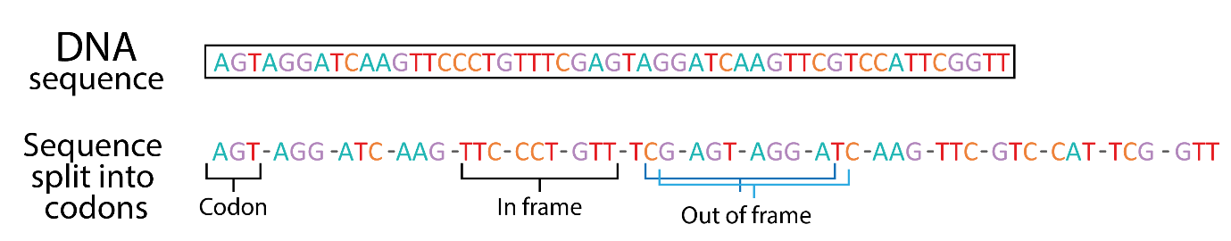
Clue 2: We have narrowed down the motif to being within these regions:
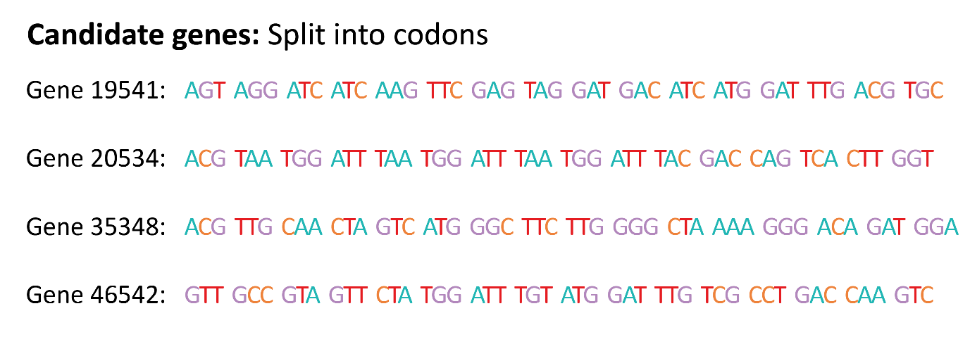
Room 2: Gene Targeting
Clue 1: Here is another plasmid I made last week along with the places where the enzyme cut the vector and the predicted DNA fragment sizes. For example, the fragment formed by cutting with enzymes 2 and 3 is 5500 – 3000 = 2500 base pairs (bp) long.
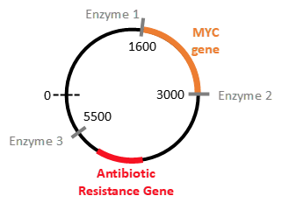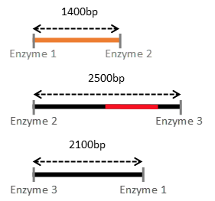
This agarose gel shows the DNA fragments created by the restriction enzymes on the above MYC plasmid. In column #4, you can see that cutting with all 3 enzymes has generated 3 fragments (shown by the 3 lines). The higher up the ladder, the longer the fragment.
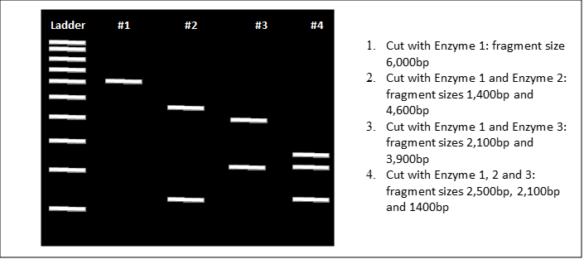
You need to work out the lengths of the DNA fragments for DNA vector 2, then work out which column of the gel (tubes 1-6) matches this.

Clue 2: This is what our vector would look like cut up with the different enzymes (enzyme 3 cuts in two different places). Which of the columns in the gel matches this?
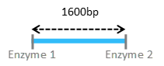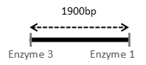
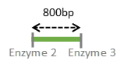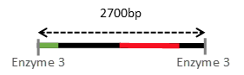

Room 3: Sequencing
Clue 1: The first codon (CGT) makes an Arginine amino acid.
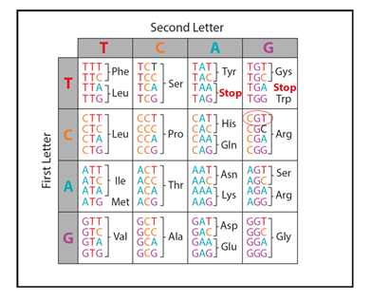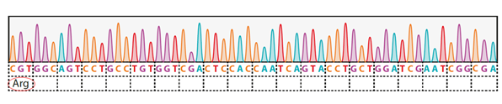
Clue 2: Here is the completed amino acid sequence, but what will this protein do? Use the table linking common domain functions to their sequences to find out. Then see which protein from the possible options this matches with.
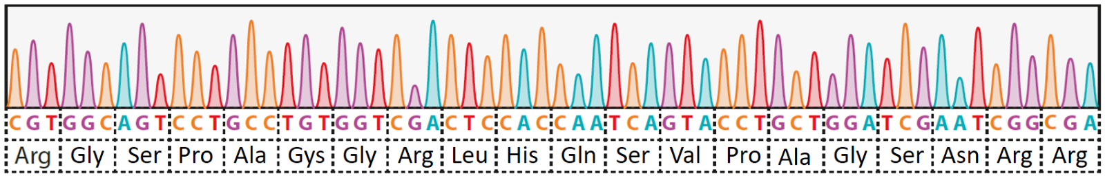For example, our completed sequence contains the Gly-Ser-Pro sequence. This corresponds to the Zinc Binding Domain, so the sequenced DNA must code for a protein which has the Zinc Binding Domain.

Room 4: Flow Cytometry and Imaging
Clue 1: Remember you can tell what colour cells are by where in the graph they appear.
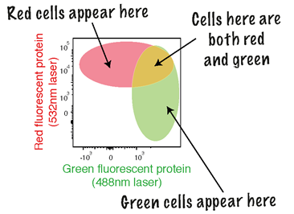

Clue 2: For example, green cells will appear in the bottom right of the graph.
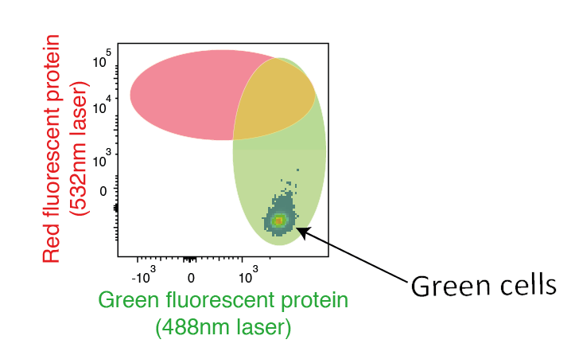

Room 5: Biochemistry lab
Clue 1: Blank spaces are cells which are NOT expressing the fluorescent protein. We want the greatest level of gene expression.
Clue 2: Higher concentrations don’t always result in higher levels of gene expression!

Room 6: Epigenetics lab
Clue 1: Remember, enhancers only work when the gene is already on!
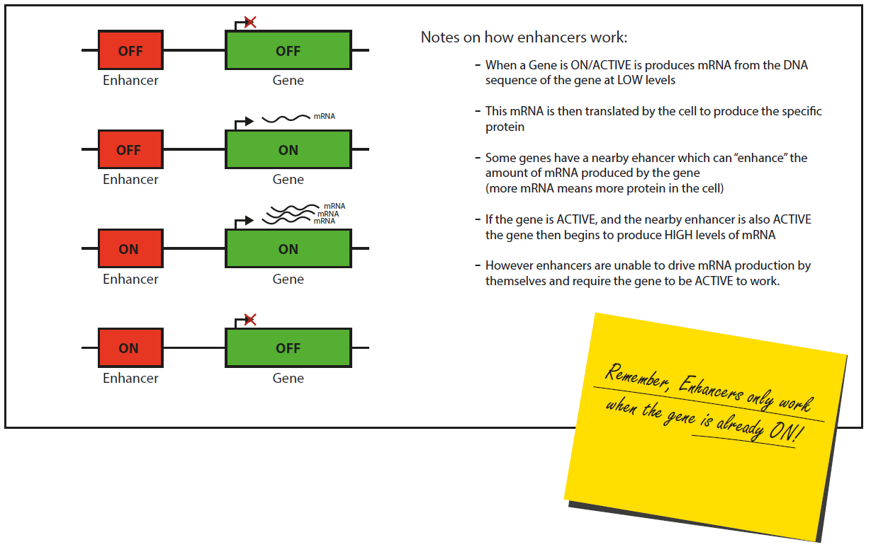
Clue 2: For Gene/Enhancer pair 2, based on the marks the Gene is ON but the Enhancer is OFF. This means the Gene will be expressed at low levels.
