BY4741 sporulation

Friday: Mix cells of tester and library strain in a patch on a YPD plate for 3-6 hours then restreak on a selective plate and grow at 30° (selection is –lys –met for normal BY4741 x BY4742 mating)

Monday, Tuesday, Wednesday: Patch a single colony onto a YPD plate overnight, then patch again on GNA overnight, and again on GNA overnight, all at 30°

Thursday: Inoculate ~1 colony-worth of cells into 2.5ml of GMM media in a 14ml tube, vortex (OD should be ~0.1-0.5), put in 25° incubator shaking at 200rpm. Make sure tube is at a shallow angle like this:

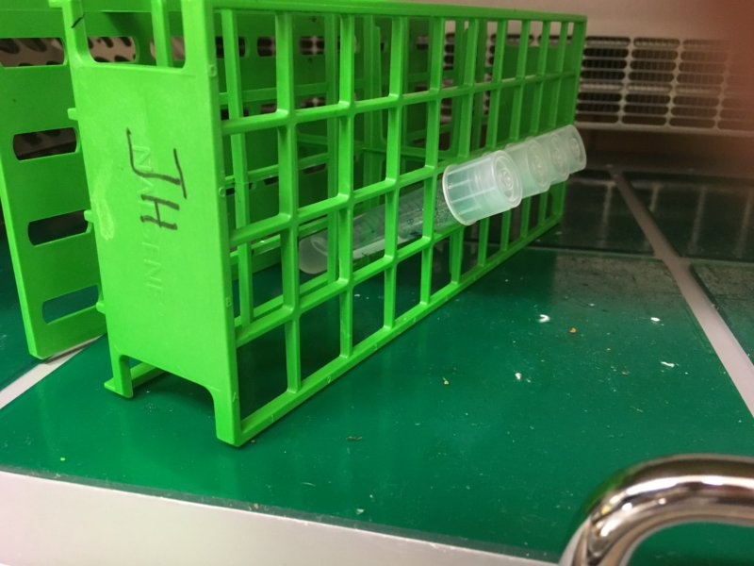

Sporulate at 25° for 3-10 days (check them under the microscope every couple of days and dissect when you have plenty of tetrads)

For tetrad dissection:

Dry some YPD plates for a few days on the bench

Mix 3µl sporulated culture, 27µl Buffer A (1.2M sorbitol, 50mM EDTA), 1µl 17U/µl high grade lyticase

Incubate 30min at RT, then streak 3µl over the appropriate area of the YPD plate

Wait for the spots to dry then dissect immediately

Media:

GNA Presporulation Plates
Final Concentrations | recipe for 2 plates | recipe for 10 plates
5% D-glucose | 5 gm | 25 gm
3% nutrient broth (powder or microgranulated) | 3 gm | 15 gm
1% yeast extract | 1 gm | 5 gm
2% agar | 2 gm | 10 gm
water to the final volume | 100 ml | 500 ml
Autoclave for 15 minutes. Plates should always be freshly made and last only for 1-2 weeks at 4°C for optimum sporulation.
Liquid Sporulation Medium
Final Concentrations | Stock solutions | recipe for 20 mls
1% Potassium Acetate | 10% Potassium Acetate (20g/200ml) | 2 mls
0.005% Zinc Acetate | 0.5% Zinc acetate (1g/200ml) | 0.2 mls
Include amino acids/nucleotides from 100x / 10x stocks to complement any homozygous auxotrophies in the diploid. Not doing this can reduce spore viability substantially.

Lyticase stock: 17U/μl lyticase (Sigma >2000 U/mg L2524)
10mM KPi pH7
50% glycerol
Store at -20°
Note calculate lyticase stock using U/mg solid

